**/Only Preview/**

**Navigation for visually impaired users based on audio-instructions of landmarks and preferable paths, given by visually impaired people. (Ongoing)**

This project aims at comparing traditional maps made by sighted people with talk back with instructions combined with sound of specific landmarks and 3D binaural environment audio to see which one has less cognitive load on a user and allows navigation with less error deviations. The idea is to observe whether these methods can create an allocentric spatial perspective in the users and with time the unavailability of any cues should also not be a problem since the information is embedded in their memory.

An allocentric representation of space would allow one to mentally explore the environment, as opposed to physically explore it, and would consequently allow for reorganization of itineraries such as alternative routes or shortcuts.

**Binaural Audio**

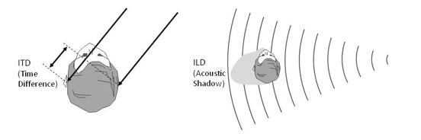

ITD and ILD. Interaural Time and Level differences (01)